Error001

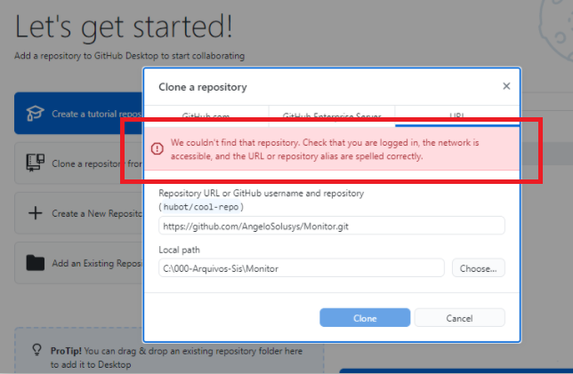

Description of the error: Unable to clone a repository

Solution: Sign-out and sign-in to your Github desktop

>> go to Github desktop

>> File

>> Options

>> Sign-out to Github.com

>> Sign-in

>> Repeat the process of cloning a repository

Error002

This is the error in browser:



View on References under WebApp (project name):

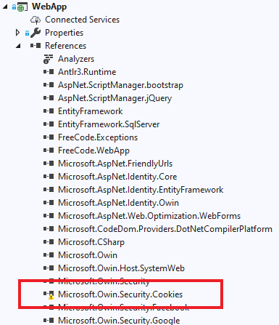

Solution: Install Microsoft.Owin.Security.Cookies

>> right click WebApp (Project name)

>> Manage NuGet Packages

>> Browse

>> Search Microsoft.Owin.Security.Cookies

>> Install